Final Assessment-Alternative Assessment
Semester | 202520 | Division | CIS
Assessment title in Syllabus | Final_Project_Portfolio | Program | Bachelor of Information Technology/ Bachelor of Information Systems
Course Code | CDS 2413
Course Title | INTRODUCTION TO DATA SCIENCE
Course Instructor |  | CRN
Assessment | Project Deliverable 1 – Data Analysis Report | Submission Date | Week 6
Student Declaration:
Academic Integrity Statement
In accordance with the HCT Academic Integrity Policy
• Students are required to refrain from all forms of academic integrity breaches as defined and explained by HCT.
• A student found guilty of having committed acts of academic integrity breach(es) will be subject to the relevant sanctions as outlined by HCT.
إفادة النزاهة الأكاديمية
وفقًا لسياسة كليات التقنية العليا للنزاهة الأكاديمية
• على الطلبة الإلتزام بلوائح وقواعد النزاهة الأكاديمية، كما هو مبيّن وموضح في السياسات والإجراءات الخاصة بكليات التقنية العليا.
• في حالة ارتكاب الطالب أي شكل من أشكال الإخلال بالنزاهة الأكاديمية، سيتعرض الى العقوبات الموضحة في السياسات ذات الصلة.
This assignment is entirely my/our own work except where I have duly acknowledged other sources in the text and listed those sources at the end of the assignment. I have not previously submitted this work to the HCT, or any other entity. I understand that I may be orally examined on my submission.

Student HCT ID(s): | H00496463 | H00498422 | H00532391 | H00542955
Student Name(s): | Mariam Abdulnaser Alkatheeri | Ayesha Khaled Almemari | Jawaher Hasan Alameri | Fatima Majed Alwahedi
Student Signature
Chatbot (e.g. ChatGPT) statement
This submission allows you to use AI generated tools, but the prompt used must be stated and the response must be in red font. Include References to ChatGPT.

Instructions

Remove instructions and hints from the template before submitting the final report to BBLearn.

CLO1: Introduction and Data Wrangling (5 Points)

Purpose of Data Analysis (1 point)

The purpose of this data analysis is to examine daily food delivery orders and identify patterns that impact order value. This analysis helps us understand customer behavior, delivery performance, and the factors that influence revenue. This information supports better business decisions. It also allows the company to recognize busy periods and customer preferences. By understanding these patterns, the business can create better strategies to boost sales and enhance service quality. Additionally, the analysis can point out areas needing improvement, such as reducing delivery time or increasing customer satisfaction. Overall, the insights gained from this data can help the company become more competitive and efficient in the food delivery market.

Type of Programming (1 point)
The programming language used for this data analysis is Python.

Justification:
Python is widely used in data science due to its simplicity, flexibility, and powerful libraries that support data analysis and machine learning tasks. It provides efficient tools for data cleaning, manipulation, visualization, and modeling. Key libraries used include:
- Pandas: for data manipulation and analysis
- NumPy: for numerical computations
- Matplotlib and Seaborn:for data visualization
- Scikit-learn: for machine learning implementation

Type and Purpose of ML algorithm (1 point)

The type of machine learning algorithm used for this dataset is Supervised Learning (Regression). Regression is selected because the dataset includes a numerical dependent variable, which is the order value, and the goal is to understand how different factors affect it.

The purpose of using this algorithm is to analyze the relationship between order value and variables such as delivery time, delivery distance, customer age, and delivery partner rating. This helps in predicting future order values and understanding which factors have the greatest impact on customer spending. The results can support better business decisions and improve overall service performance.

Identify the Varaibles (1 point)

Dependent Variable:
The dependent variable in this dataset is order value, as it represents the outcome that the analysis aims to study and predict. It shows how much customers spend on each food delivery order.

Independent Variables:
The independent variables include customer age, delivery distance, delivery time, delivery partner rating, restaurant type, and payment method. These variables are considered independent because they may influence or affect the order value but are not controlled by it.

Justification:
The independent variables are selected because they represent customer characteristics and delivery conditions that can impact spending behavior. By analyzing these variables, we can understand which factors contribute most to changes in order value and support better business decision-making.

Sampling (1 point)

Yes, sampling will be used in this dataset to analyze a smaller portion of the data while still representing the overall orders.
The sampling method used is random sampling, where each record has an equal chance of being selected. This helps ensure that the sample is fair and unbiased.

Justification:
Random sampling is chosen because it represents the dataset accurately and makes the analysis faster and easier without affecting the reliability of the results.

CLO2: Descriptive, Exploratory and Statistical Analysis (10 Points)

Purpose of Descriptive Analysis (1 point)

The reason why we need to perform a descriptive analysis on our food delivery data is to assist us in organizing and summarizing the large list of orders so that we can better understand it. Through the use of the mean and median, I am able to determine the average amount that customers pay for their orders. In addition, through the use of the standard deviation and range, I am able to determine whether there is a large difference between the lowest and highest orders or whether most orders are around the same amount. This is a very crucial step in allowing us to determine the general trends of the data before we proceed to perform further testing.

Script for Descriptive Analysis (1 point)
#importing
import pandas as pd

# loading data
delivery_df = pd.read_csv('daily_food_delivery_orders.csv')

# define function
def desc_stat(ds, var):
print("Variable: ", var)
print("Mean: ", ds[var].mean())
print("Median: ", ds[var].median())
print("Standard Deviation: ", ds[var].std())
print("Min: ", ds[var].min())
print("Max: ", ds[var].max())
print("Range: ", ds[var].max() - ds[var].min())

Random Sampling (1 point)

# create random sampling
#sample of size 150
random_sample = delivery_df.sample(n=150)
desc_stat(random_sample, 'order_value')

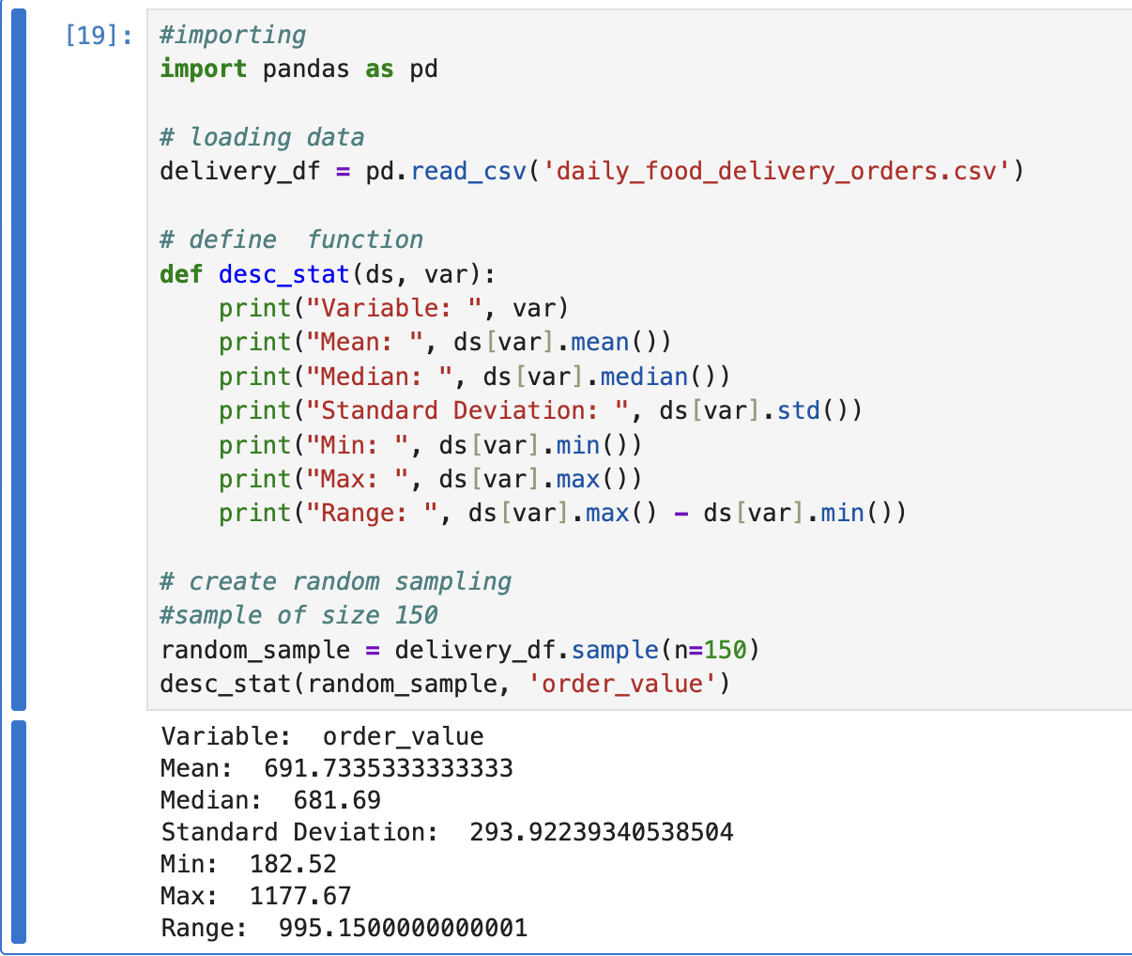

Because we are using random sampling, the results will change slightly every time the code is run since it selects a different set of 150 orders each time.

Systematic Sampling (1 point)

To choose a structured subset of the dataset's observations, systematic sampling was used. Systematic sampling chooses every k-th record after establishing a predetermined interval, in contrast to random sampling.

N= is the total number of records.
n = 150 is the desired sample size.

This technique minimizes clustering bias and guarantees that the sample is distributed uniformly throughout the dataset.

# Systematic Sampling
N = len(df)
n = 150
k = N // n

systematic_sample =df.iloc[::k]
df

systematic_sample = systematic_sample.head(150)
df

desc_stat(systematic_sample["order_value"])

Justification:

Systematic sampling maintains representativeness while increasing efficiency. It is suitable for huge operational datasets like daily food delivery orders since it guarantees coverage over the entire dataset.

Descriptive Statistical Report (1 point)

The primary revenue indication for the food delivery company is the dependent variable order value, which shows how much each customer spends.

The results of the descriptive analysis show:

Mean: Shows the typical amount of money spent by customers.
The median helps determine skewness by indicating the central value.
The standard deviation quantifies the shift in consumer expenditure.
Range: Indicates the difference between the lowest and highest order values.

High-value orders are present in a positively skewed distribution when the mean is higher than the median.
A high standard deviation indicates that consumer purchasing patterns are very unpredictable.

Interpretation for Business:

This analysis gives details on:

- Typical consumer purchasing patterns
- Variability in spending by client
- Existence of sectors with high or low spending
- Patterns of revenue stability
- Demand forecasting, price strategy, and promotion planning are all aided by an understanding of this information.

Visualisation through Various Charts (2 points)

For this part of our project, we used Matplotlib and Seaborn to create visual graphs from our delivery data.
We thought it was a good idea to visualize what the "order_value" really is instead of just looking at a bunch of numbers in our table. By analyzing all four of these graphs, we were able to determine if most orders are around the same price point, if large delivery distances correlate to increased spending, and if there are any outliers in our data. These graphs allow us to easily interpret our results and pick up on trends in customer behavior.

import matplotlib.pyplot as plt
import seaborn as sns
#importing
import pandas as pd

# loading data
delivery_df = pd.read_csv('daily_food_delivery_orders.csv')

# a. Scatter plot
plt.figure(figsize=(6,4))
df.plot.scatter (x="delivery_time_minutes", y="order_value", c="red")

# b. Box Plot
sns.boxplot (x=df ["order_value"])
plt.title( "Box Plot of Order Values")
plt.xlabel("Order Value")

# c. Histogram
plt.hist (df ["order_value" ] , bins=3, edgecolor= "black")
plt.xlabel("Order Value")
plt.ylabel("Frequency")
plt.title ("Distribution of Order Values")

# d. Heat Map
plt.figure(figsize=(10,7))
heatmap_data = df.pivot_table(
index="restaurant_type",
columns="payment_method",
values="order_value",
aggfunc="sum"
)

plt.figure(figsize=(10,6))

sns.heatmap(
heatmap_data,
annot=True,
fmt=".0f",
cmap="coolwarm",
cbar_kws={'label': 'Total Order Value'}
)

plt.title("Total Order Value by Restaurant Type and Payment Method")
plt.ylabel("Restaurant Type")
plt.xlabel("Payment Method")
plt.show()

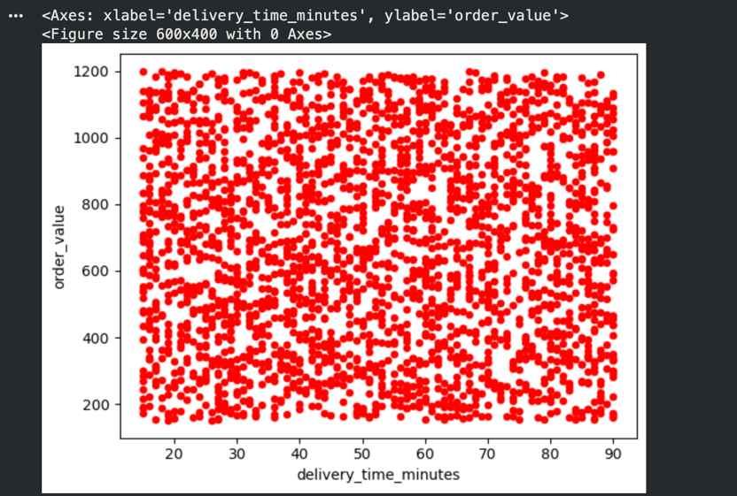

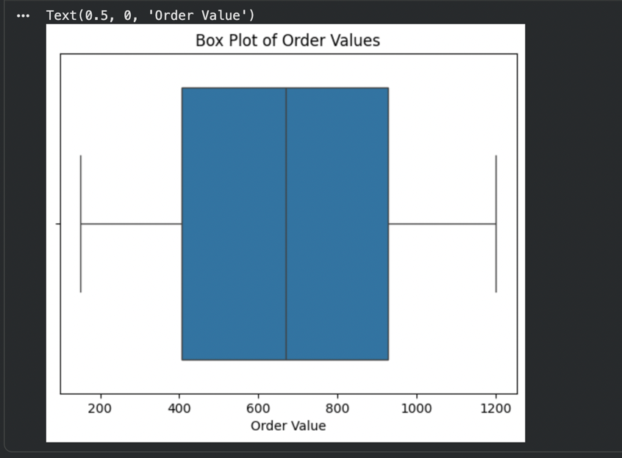

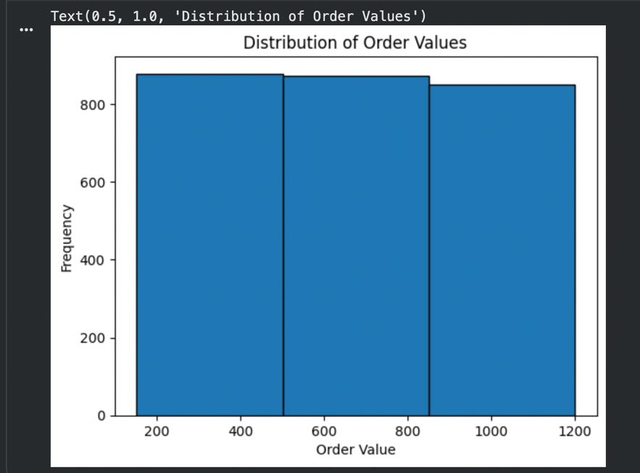

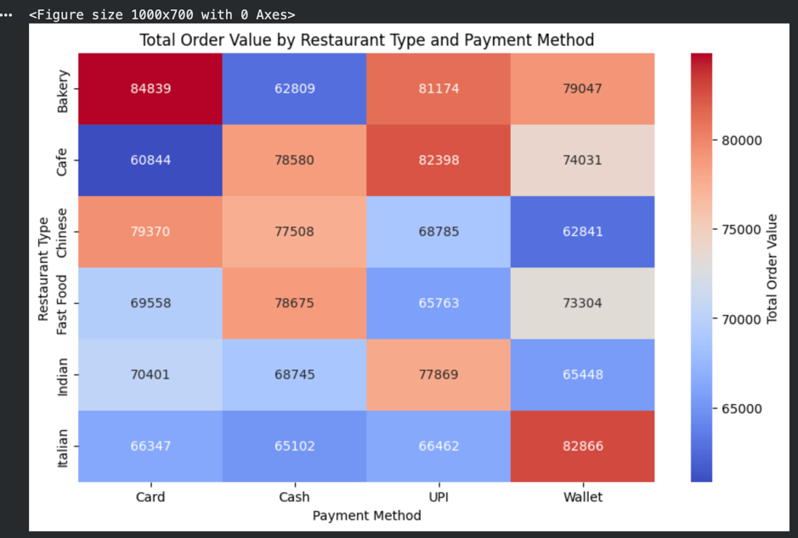

Hypothesis Test (1 point)

There is no significant relationship between delivery time and order value.
There is a significant relationship between delivery time and order value.
If p-value < 0.05, reject H0.
from scipy.stats import pearsonr, spearmanr
pearson_corr, pearson_p = pearsonr(df["delivery_time_minutes"], df["order_value"])
df
spearman_corr, spearman_p = spearmanr(df["delivery_distance_km"], df["order_value"])
df
print("Pearson Correlation:", pearson_corr)
print("Pearson P-value:", pearson_p)
print("Spearman Correlation:", spearman_corr)
print("Spearman P-value:", spearman_p)

One Sample T-test (2 points)
<< Assess the performance of the dependent variable to know whether the sample is representative of the normal population by a one-sample t-test..>>

H0: Sample mean order value equals population mean.
H1: Sample mean order value is different from population mean.
If p-value > 0.05, the sample represents the population.
from scipy.stats import ttest_1samp
population_mean = 50
t_stat, p_value = ttest_1samp(random_sample[“order_value”], population_mean)
print("T-statistic:", t_stat)
print("P-value:", p_value)

End of Documentation.

